**LP6 (Test on Edge Browser)**

**1.Verify the Header-**

(a) Logo should redirect to the correct link.

Yes, is working fine and redirect to the correct link.

(b) Logo link should open in a new tab.

Yes, logo will be opened in the new tab, which is not same as given page.

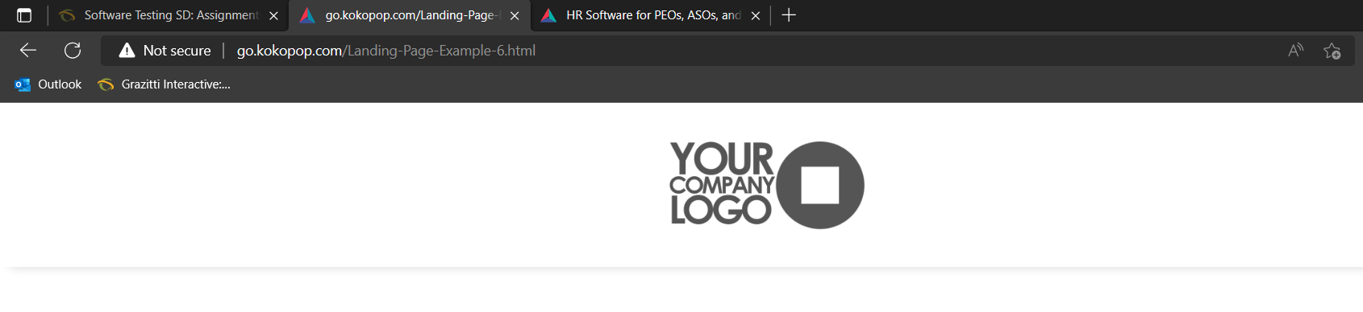

**2.Verify the Footer-**

(a) Verify redirection of Links and content.

Link and Content is working fine, it redirects to another page in different tab only.

(b) Verify social icons' redirection.

There is no Social Icon is there in footer, add these social icons.



**3.Verify Correct Favicon- Favicon should be the same as it is on the client's live website.**

Yes, Favicon is present on the website.

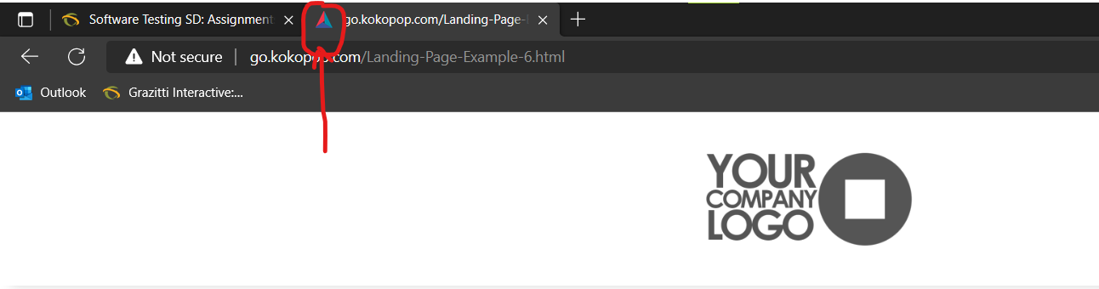

**4.Verify the Font-family- Verify font family is consistent throughout(unless special   requirement by client).**

Font Family of the website is good. Size and color are also good.

**5.Verify the redirection of links-**

(a) All CTAs, links and icons should redirect to correct pages.

Yes, all CTA and icons will be redirect to the correct page.

(b) Add note to developer if # is used for links.

‘#’ is not present in all the links.

**6.Verify the Spacing - Verify Spacing and alignment of the page should not break.**

Spacing and Alignment of the page is correct. If user wants to change then change as per your choice

**7.Verify Form-**

(a) Verify alignment and spacing of form.

The alignment and spacing of the form is good.

(b) Verify * is used for Mandatory Fields.

No, it is not used for mandatory fields. ‘@’ is used in the mandatory field.

(c) Verify it is showing correct error messages.

Yes, it is showing the error message, when we fill the incorrect email or not fill the any checkbox.

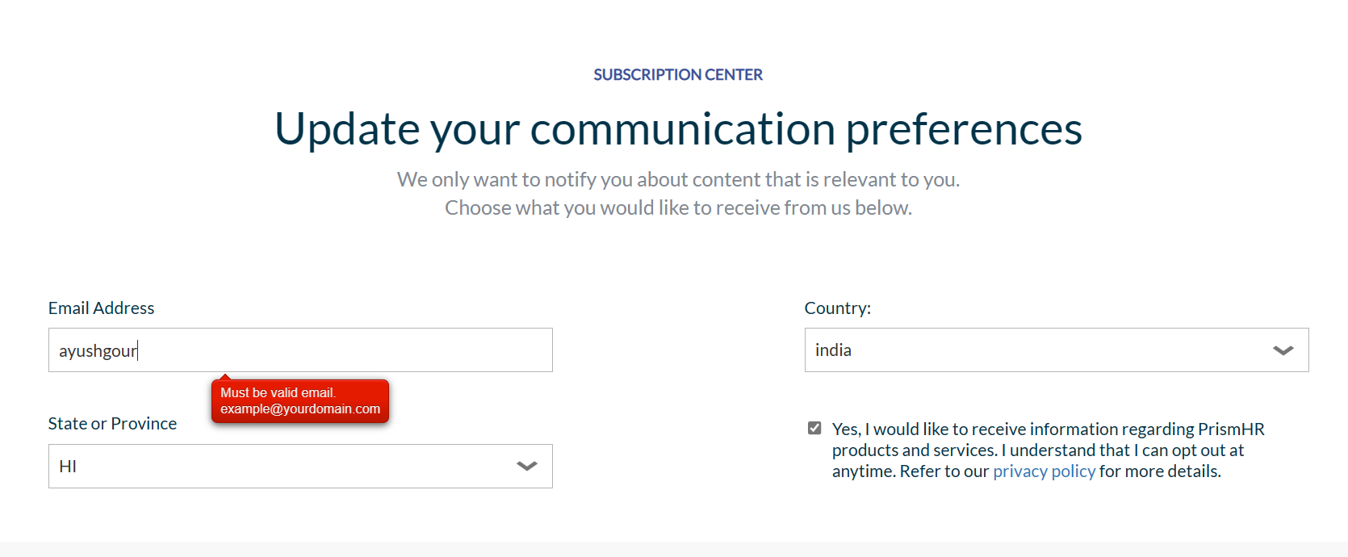

**8.Verify Thank you message after submitting form- If Required.**

Yes, it is shown when we submit the form.

**9.Verify Landing page on cross browsers- Google Chrome, Firefox, Internet Explorer and MAC (Safari).**

Landing Page is working on all browsers Google, Chrome, Firebox and Edge.

**10.Verify Responsive- Verify it on iPhone and iPad on simulator or live device.**